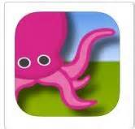
Green Screen by DoInk

- Obtain a green screen, fabric or Green table cloth.
- Save an image to the camera roll for your background.
- Record a video using the camera on the iPad with the green screen as your background.
- Open the Green screen app.
- Add videos, pictures and animation. Note keep videos to less than 3 minutes. Makes it much easier for uploading and editing purposes.
Middle-This is where you add the videos. You can’t edit videos in this app, but can if imported to iMovie.
Top- This is where students can put animation that they created using the DoInk animation app. This is an advanced feature to play with later.
- Upload to camera roll.
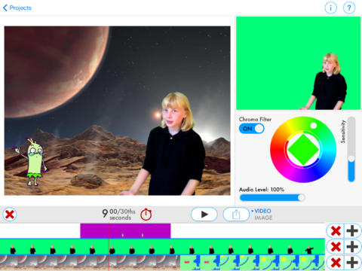
- Edit in iMovie. Add text, music or combine videos. Can put into other apps such as Book Creator and Keynote.

Bottom-This is where you can put the background. The easiest is a picture. More advanced , but possible is a video. This will appear behind you. You can use multiple images even if the video does not change.

Upload to camera roll. Medium size works fine.

